[Transfer Learning for Image Classification in PyTorch](https://jovian.ai/aakashns/transfer-learning-pytorch" \l "C0)

[Downloading the Dataset](https://jovian.ai/aakashns/transfer-learning-pytorch#C1)

[Creating a Custom PyTorch Dataset](https://jovian.ai/aakashns/transfer-learning-pytorch#C11)

[Creating Training and Validation Sets](https://jovian.ai/aakashns/transfer-learning-pytorch#C17)

[Modifying a Pretrained Model (ResNet34)](https://jovian.ai/aakashns/transfer-learning-pytorch#C23)

[GPU Utilities and Training Loop](https://jovian.ai/aakashns/transfer-learning-pytorch#C26)

[Finetuning the Pretrained Model](https://jovian.ai/aakashns/transfer-learning-pytorch#C31)

[Training a model from scratch](https://jovian.ai/aakashns/transfer-learning-pytorch#C36)

## Transfer Learning for Image Classification in PyTorch

How a CNN learns ([source](https://jovian.ai/outlink?url=https%3A%2F%2Fdeveloper.nvidia.com%2Fdiscover%2Fconvolutional-neural-network)):

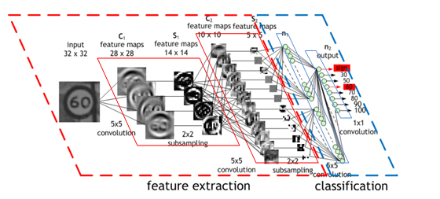

Layer visualization ([source](https://jovian.ai/outlink?url=https%3A%2F%2Fmedium.com%2Fanalytics-vidhya%2Fdeep-learning-visualization-and-interpretation-of-neural-networks-2f3f82f501c5)):

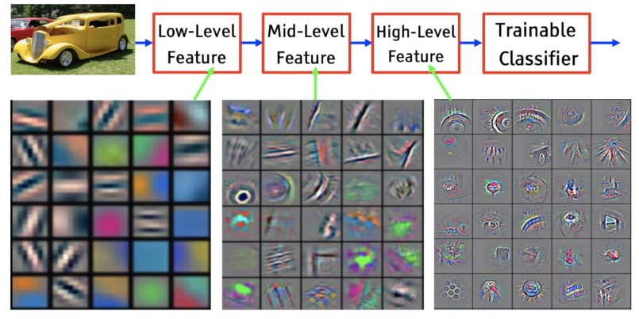

### Downloading the Dataset

We'll use the Oxford-IIIT Pets dataset from [https://course.fast.ai/datasets](https://jovian.ai/outlink?url=https%3A%2F%2Fcourse.fast.ai%2Fdatasets) . It is 37 category (breeds) pet dataset with roughly 200 images for each class. The images have a large variations in scale, pose and lighting.

!pip install jovian --upgrade --quiet

from torchvision.datasets.utils import download_url

download_url('https://s3.amazonaws.com/fast-ai-imageclas/oxford-iiit-pet.tgz', '.')

Using downloaded and verified file: ./oxford-iiit-pet.tgz

import tarfile

with tarfile.open('./oxford-iiit-pet.tgz', 'r:gz') as tar:

tar.extractall(path='./data')

from torch.utils.data import Dataset

import os

DATA_DIR = './data/oxford-iiit-pet/images'

files = os.listdir(DATA_DIR)

files[:5]

['pug_189.jpg',

'newfoundland_110.jpg',

'Maine_Coon_52.jpg',

'leonberger_70.jpg',

'japanese_chin_23.jpg']

def **parse_breed**(fname):

parts = fname.split('_')

return ' '.join(parts[:-1])

parse_breed(files[4])

'japanese chin'

from PIL import Image

def **open_image**(path):

with open(path, 'rb') as f:

img = Image.open(f)

return img.convert('RGB')

### Creating a Custom PyTorch Dataset

import os

class **PetsDataset**(Dataset):

def **__init__**(self, root, transform):

super().__init__()

self.root = root

self.files = [fname for fname in os.listdir(root) if fname.endswith('.jpg')]

self.classes = list(set(parse_breed(fname) for fname in files))

self.transform = transform

def **__len__**(self):

return len(self.files)

def **__getitem__**(self, i):

fname = self.files[i]

fpath = os.path.join(self.root, fname)

img = self.transform(open_image(fpath))

class_idx = self.classes.index(parse_breed(fname))

return img, class_idx

import torchvision.transforms as T

img_size = 224

imagenet_stats = ([0.485, 0.456, 0.406], [0.229, 0.224, 0.225])

dataset = PetsDataset(DATA_DIR, T.Compose([T.Resize(img_size),

T.Pad(8, padding_mode='reflect'),

T.RandomCrop(img_size),

T.ToTensor(),

T.Normalize(*imagenet_stats)]))

len(dataset)

7390

import torch

import matplotlib.pyplot as plt

%matplotlib inline

def **denormalize**(images, means, stds):

if len(images.shape) == 3:

images = images.unsqueeze(0)

means = torch.tensor(means).reshape(1, 3, 1, 1)

stds = torch.tensor(stds).reshape(1, 3, 1, 1)

return images * stds + means

def **show_image**(img_tensor, label):

print('Label:', dataset.classes[label], '(' + str(label) + ')')

img_tensor = denormalize(img_tensor, *imagenet_stats)[0].permute((1, 2, 0))

plt.imshow(img_tensor)

show_image(*dataset[2])

Label: Maine Coon (32)

### Creating Training and Validation Sets

from torch.utils.data import random_split

val_pct = 0.1

val_size = int(val_pct * len(dataset))

train_ds, valid_ds = random_split(dataset, [len(dataset) - val_size, val_size])

from torch.utils.data import DataLoader

batch_size = 256

train_dl = DataLoader(train_ds, batch_size, shuffle=True, num_workers=4, pin_memory=True)

valid_dl = DataLoader(valid_ds, batch_size*2, num_workers=4, pin_memory=True)

from torchvision.utils import make_grid

def **show_batch**(dl):

for images, labels in dl:

fig, ax = plt.subplots(figsize=(16, 16))

ax.set_xticks([]); ax.set_yticks([])

images = denormalize(images[:64], *imagenet_stats)

ax.imshow(make_grid(images, nrow=8).permute(1, 2, 0))

break

show_batch(train_dl)

Output hidden; open in [https://colab.research.google.com](https://jovian.ai/outlink?url=https%3A%2F%2Fcolab.research.google.com) to view.

### Modifying a Pretrained Model (ResNet34)

Transfer learning ([source](https://jovian.ai/outlink?url=https%3A%2F%2Fmc.ai%2Ftransfer-learning-with-deep-learning-machine-learning-techniques%2F)):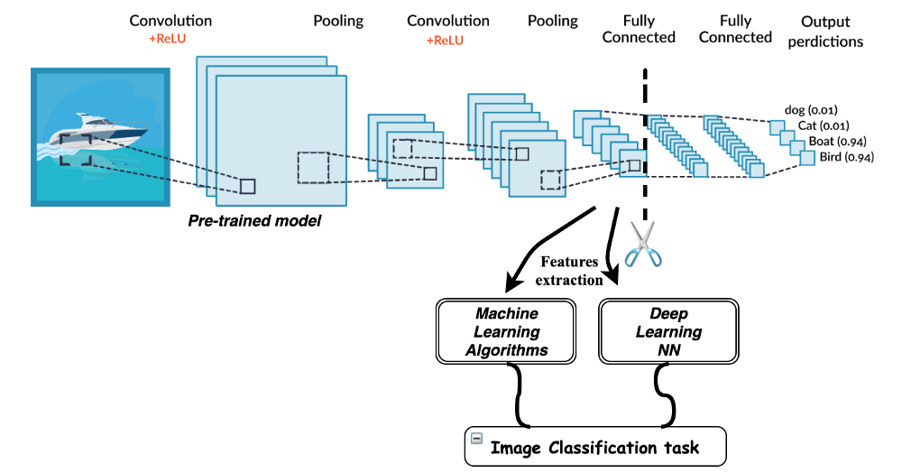

import torch.nn as nn

import torch.nn.functional as F

def **accuracy**(outputs, labels):

_, preds = torch.max(outputs, dim=1)

return torch.tensor(torch.sum(preds == labels).item() / len(preds))

class **ImageClassificationBase**(nn.Module):

def **training_step**(self, batch):

images, labels = batch

out = self(images) *# Generate predictions*

loss = F.cross_entropy(out, labels) *# Calculate loss*

return loss

def **validation_step**(self, batch):

images, labels = batch

out = self(images) *# Generate predictions*

loss = F.cross_entropy(out, labels) *# Calculate loss*

acc = accuracy(out, labels) *# Calculate accuracy*

return {'val_loss': loss.detach(), 'val_acc': acc}

def **validation_epoch_end**(self, outputs):

batch_losses = [x['val_loss'] for x in outputs]

epoch_loss = torch.stack(batch_losses).mean() *# Combine losses*

batch_accs = [x['val_acc'] for x in outputs]

epoch_acc = torch.stack(batch_accs).mean() *# Combine accuracies*

return {'val_loss': epoch_loss.item(), 'val_acc': epoch_acc.item()}

def **epoch_end**(self, epoch, result):

print("Epoch [{}],{} train_loss: {:.4f}, val_loss: {:.4f}, val_acc: {:.4f}".format(

epoch, "last_lr: {:.5f},".format(result['lrs'][-1]) if 'lrs' in result else '',

result['train_loss'], result['val_loss'], result['val_acc']))

from torchvision import models

class **PetsModel**(ImageClassificationBase):

def **__init__**(self, num_classes, pretrained=True):

super().__init__()

*# Use a pretrained model*

self.network = models.resnet34(pretrained=pretrained)

*# Replace last layer*

self.network.fc = nn.Linear(self.network.fc.in_features, num_classes)

def **forward**(self, xb):

return self.network(xb)

### GPU Utilities and Training Loop

def **get_default_device**():

"""Pick GPU if available, else CPU"""

if torch.cuda.is_available():

return torch.device('cuda')

else:

return torch.device('cpu')

def **to_device**(data, device):

"""Move tensor(s) to chosen device"""

if isinstance(data, (list, tuple)):

return [to_device(x, device) for x in data]

return data.to(device, non_blocking=True)

class **DeviceDataLoader**():

"""Wrap a dataloader to move data to a device"""

def **__init__**(self, dl, device):

self.dl = dl

self.device = device

def **__iter__**(self):

"""Yield a batch of data after moving it to device"""

for b in self.dl:

yield to_device(b, self.device)

def **__len__**(self):

"""Number of batches"""

return len(self.dl)

import torch

from tqdm.notebook import tqdm

**@torch.no_grad()**

def **evaluate**(model, val_loader):

model.eval()

outputs = [model.validation_step(batch) for batch in val_loader]

return model.validation_epoch_end(outputs)

def **fit**(epochs, lr, model, train_loader, val_loader, opt_func=torch.optim.SGD):

history = []

optimizer = opt_func(model.parameters(), lr)

for epoch in range(epochs):

*# Training Phase*

model.train()

train_losses = []

for batch in tqdm(train_loader):

loss = model.training_step(batch)

train_losses.append(loss)

loss.backward()

optimizer.step()

optimizer.zero_grad()

*# Validation phase*

result = evaluate(model, val_loader)

result['train_loss'] = torch.stack(train_losses).mean().item()

model.epoch_end(epoch, result)

history.append(result)

return history

def **get_lr**(optimizer):

for param_group in optimizer.param_groups:

return param_group['lr']

def **fit_one_cycle**(epochs, max_lr, model, train_loader, val_loader,

weight_decay=0, grad_clip=None, opt_func=torch.optim.SGD):

torch.cuda.empty_cache()

history = []

*# Set up custom optimizer with weight decay*

optimizer = opt_func(model.parameters(), max_lr, weight_decay=weight_decay)

*# Set up one-cycle learning rate scheduler*

sched = torch.optim.lr_scheduler.OneCycleLR(optimizer, max_lr, epochs=epochs,

steps_per_epoch=len(train_loader))

for epoch in range(epochs):

*# Training Phase*

model.train()

train_losses = []

lrs = []

for batch in tqdm(train_loader):

loss = model.training_step(batch)

train_losses.append(loss)

loss.backward()

*# Gradient clipping*

if grad_clip:

nn.utils.clip_grad_value_(model.parameters(), grad_clip)

optimizer.step()

optimizer.zero_grad()

*# Record & update learning rate*

lrs.append(get_lr(optimizer))

sched.step()

*# Validation phase*

result = evaluate(model, val_loader)

result['train_loss'] = torch.stack(train_losses).mean().item()

result['lrs'] = lrs

model.epoch_end(epoch, result)

history.append(result)

return history

device = get_default_device()

device

device(type='cuda')

train_dl = DeviceDataLoader(train_dl, device)

valid_dl = DeviceDataLoader(valid_dl, device)

### Finetuning the Pretrained Model

model = PetsModel(len(dataset.classes))

to_device(model, device);

history = [evaluate(model, valid_dl)]

history

[{'val_acc': 0.02591117098927498, 'val_loss': 3.8896164894104004}]

epochs = 6

max_lr = 0.01

grad_clip = 0.1

weight_decay = 1e-4

opt_func = torch.optim.Adam

%%time

history += fit_one_cycle(epochs, max_lr, model, train_dl, valid_dl,

grad_clip=grad_clip,

weight_decay=weight_decay,

opt_func=opt_func)

HBox(children=(FloatProgress(value=0.0, max=26.0), HTML(value='')))

Epoch [0],last_lr: 0.00589, train_loss: 1.3628, val_loss: 165.6215, val_acc: 0.0240

HBox(children=(FloatProgress(value=0.0, max=26.0), HTML(value='')))

Epoch [1],last_lr: 0.00994, train_loss: 1.9505, val_loss: 4.8602, val_acc: 0.0447

HBox(children=(FloatProgress(value=0.0, max=26.0), HTML(value='')))

Epoch [2],last_lr: 0.00812, train_loss: 1.3101, val_loss: 1.8901, val_acc: 0.4405

HBox(children=(FloatProgress(value=0.0, max=26.0), HTML(value='')))

Epoch [3],last_lr: 0.00463, train_loss: 0.8174, val_loss: 1.1133, val_acc: 0.6309

HBox(children=(FloatProgress(value=0.0, max=26.0), HTML(value='')))

Epoch [4],last_lr: 0.00133, train_loss: 0.4924, val_loss: 0.6684, val_acc: 0.7638

HBox(children=(FloatProgress(value=0.0, max=26.0), HTML(value='')))

Epoch [5],last_lr: 0.00000, train_loss: 0.3033, val_loss: 0.5651, val_acc: 0.8167 CPU times: user 49.4 s, sys: 37.7 s, total: 1min 27s Wall time: 2min 59s

### Training a model from scratch

Let's repeat the training without using weights from the pretrained ResNet34 model.

model2 = PetsModel(len(dataset.classes), pretrained=False)

to_device(model2, device);

history2 = [evaluate(model2, valid_dl)]

history2

[{'val_acc': 0.02223292924463749, 'val_loss': 64.20709228515625}]

%%time

history2 += fit_one_cycle(epochs, max_lr, model2, train_dl, valid_dl,

grad_clip=grad_clip,

weight_decay=weight_decay,

opt_func=opt_func)

HBox(children=(FloatProgress(value=0.0, max=26.0), HTML(value='')))

Epoch [0],last_lr: 0.00589, train_loss: 3.5621, val_loss: 570.1448, val_acc: 0.0227

HBox(children=(FloatProgress(value=0.0, max=26.0), HTML(value='')))

Epoch [1],last_lr: 0.00994, train_loss: 3.4390, val_loss: 4.6319, val_acc: 0.0438

HBox(children=(FloatProgress(value=0.0, max=26.0), HTML(value='')))

Epoch [2],last_lr: 0.00812, train_loss: 3.2430, val_loss: 3.2921, val_acc: 0.1269

HBox(children=(FloatProgress(value=0.0, max=26.0), HTML(value='')))

Epoch [3],last_lr: 0.00463, train_loss: 2.9670, val_loss: 3.0076, val_acc: 0.1647

HBox(children=(FloatProgress(value=0.0, max=26.0), HTML(value='')))

Epoch [4],last_lr: 0.00133, train_loss: 2.7464, val_loss: 2.9556, val_acc: 0.1672

HBox(children=(FloatProgress(value=0.0, max=26.0), HTML(value='')))

Epoch [5],last_lr: 0.00000, train_loss: 2.5684, val_loss: 2.6616, val_acc: 0.2449 CPU times: user 48.9 s, sys: 37.4 s, total: 1min 26s Wall time: 2min 57s

While the pretrained model reached an accuracy of 80% in less than 3 minutes, the model without pretrained weights could only reach an accuracy of 24%.